**Lab Assignment 3**

**Akshay Kumar Reddy G**

**Class Id: 11 (16231179)**

**Introduction:**

In this assignment I have implemented CNN, RNN and LSTM on IMDB dataset and finally drew, compared the accuracy results on these text classification techniques.

**Input:**

|  |  |  |
| --- | --- | --- |
| **Text Classification Technique** | **Dataset** | **No. of Epoch** |
| CNN | IMDB | 2 |
| LSTM | IMDB | 15 |
| RNN | IMDB | 2 |

CNN:

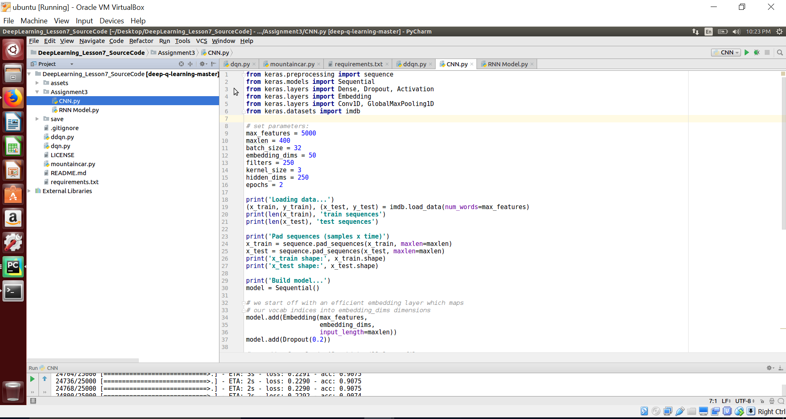

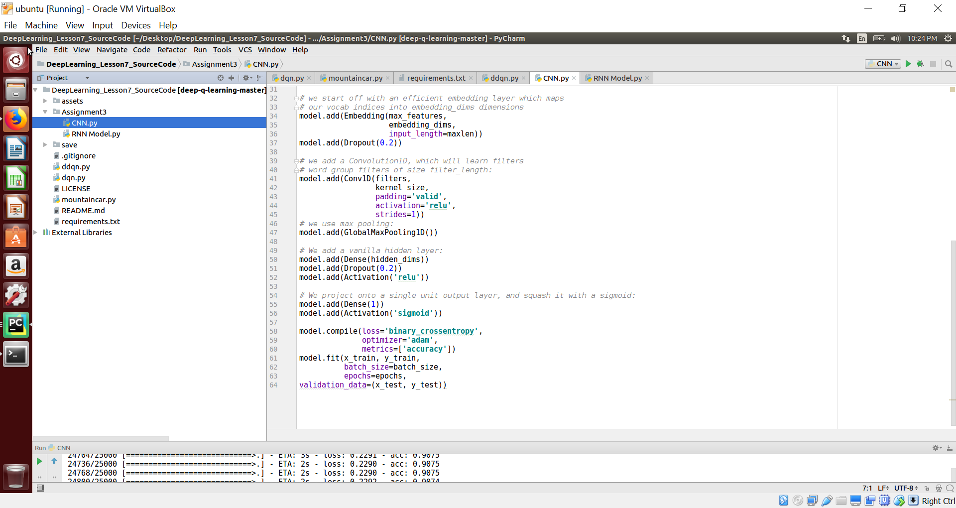

Output:

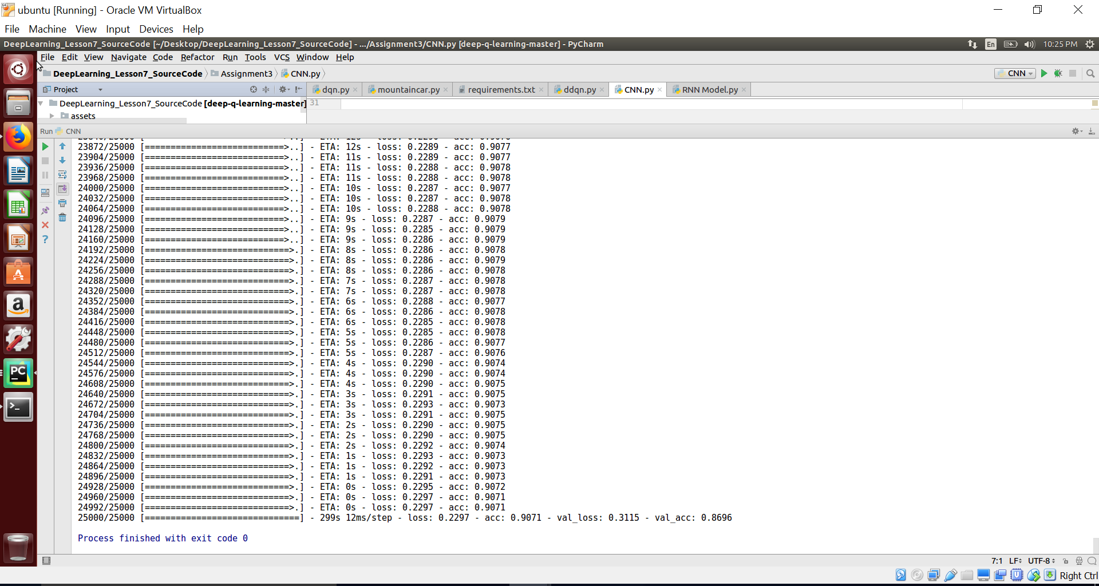

Accuracy for CNN: 0.8696 Loss: 0.3115

LSTM:

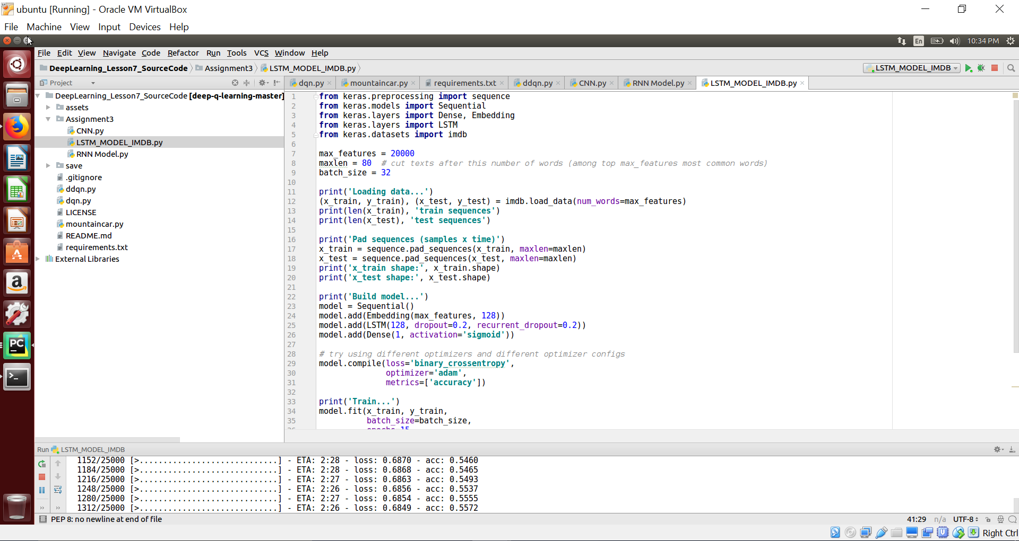

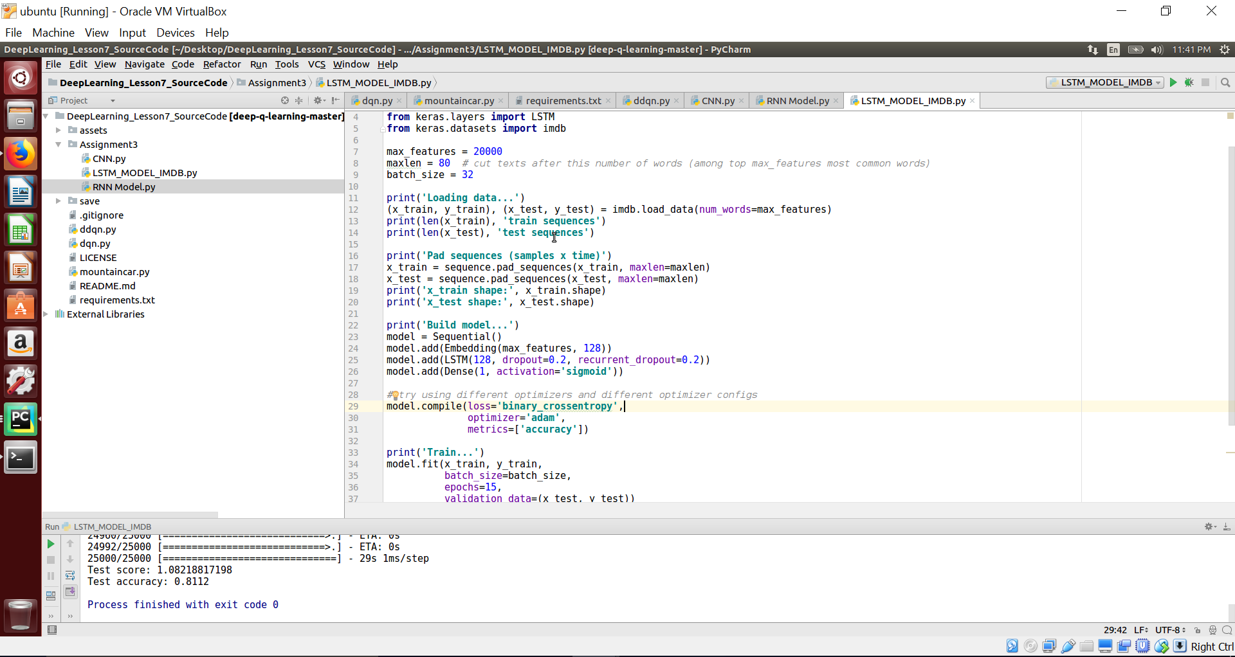

Output:

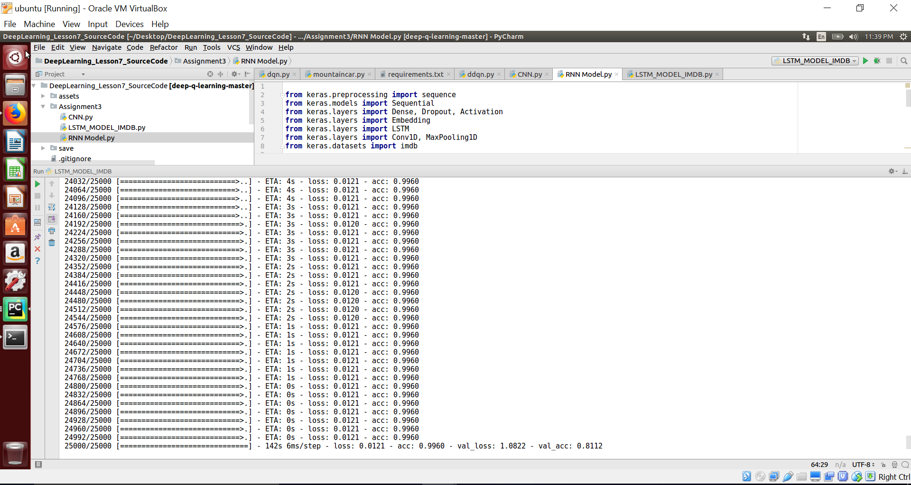

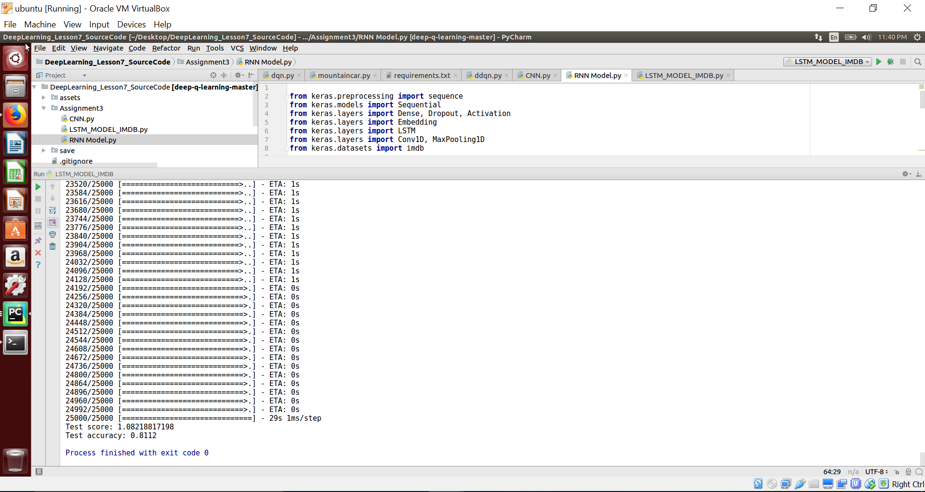

Accuracy of LSTM: 0.8112 Loss: 1.0822

RNN:

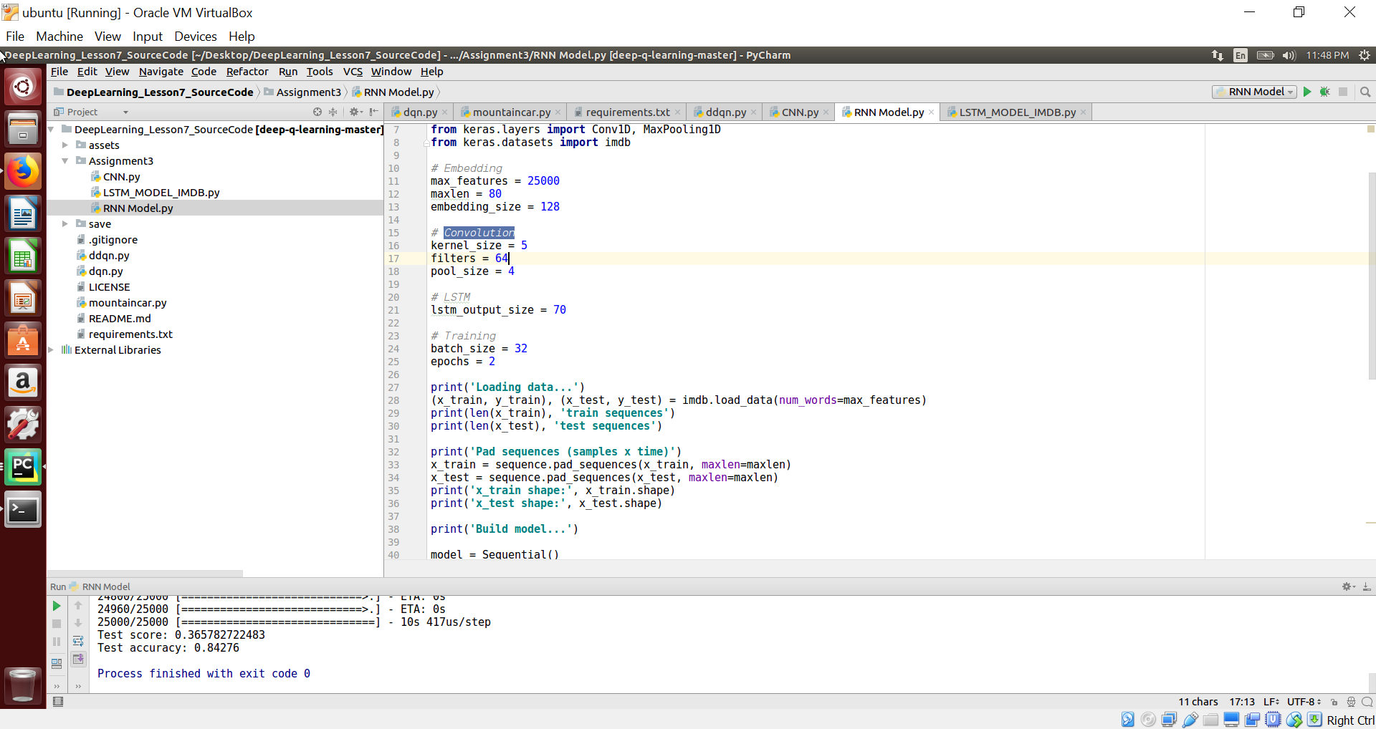

Output:

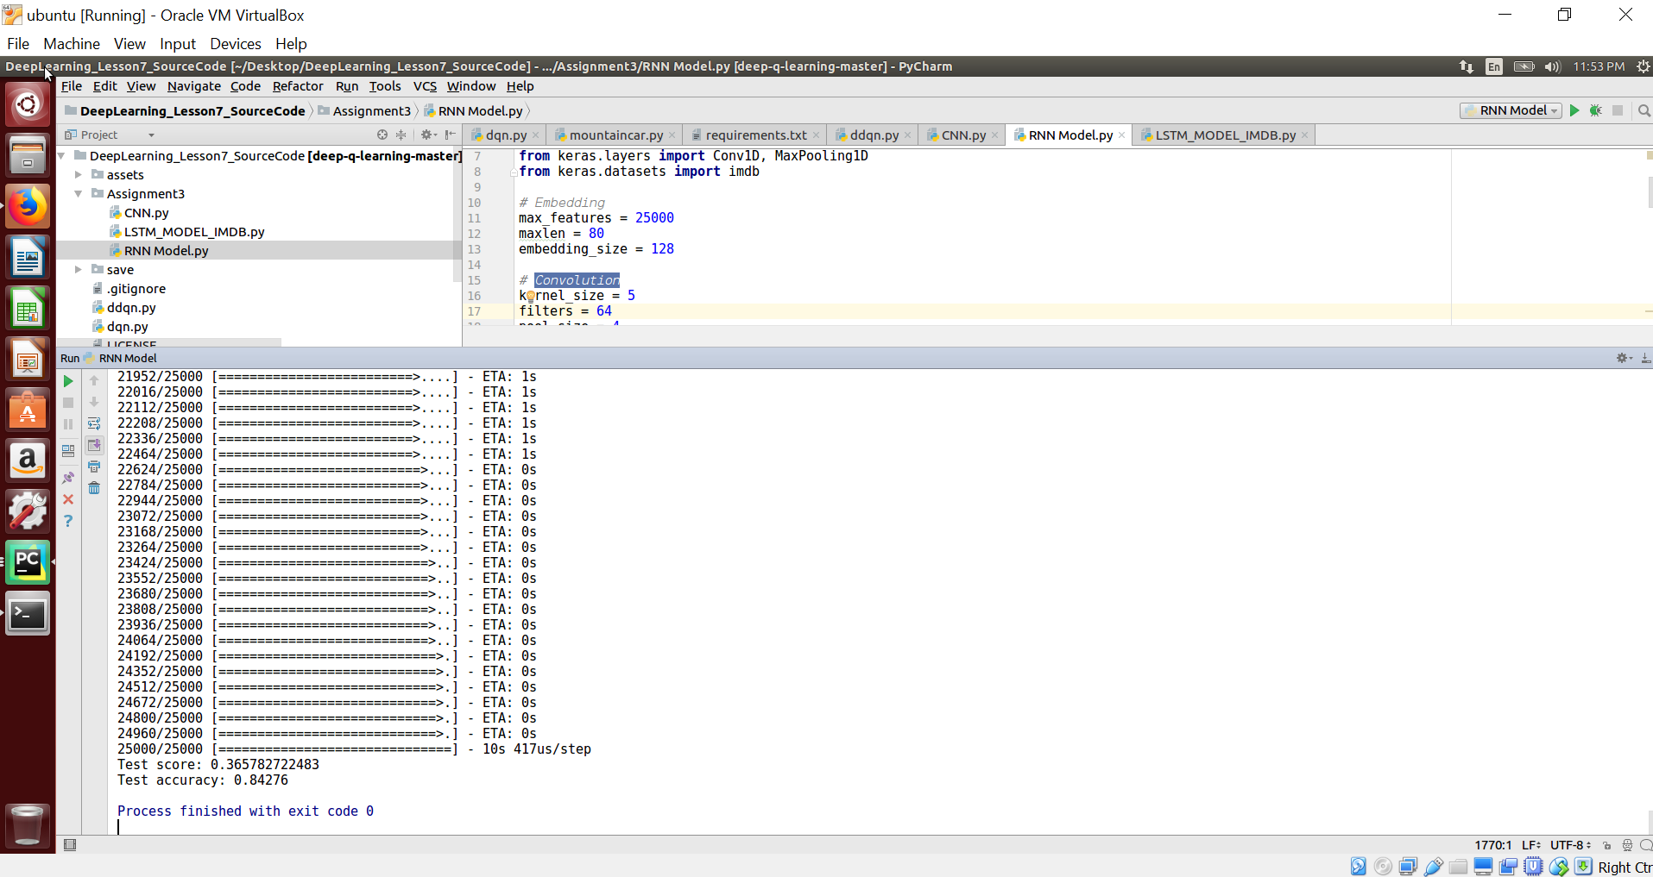

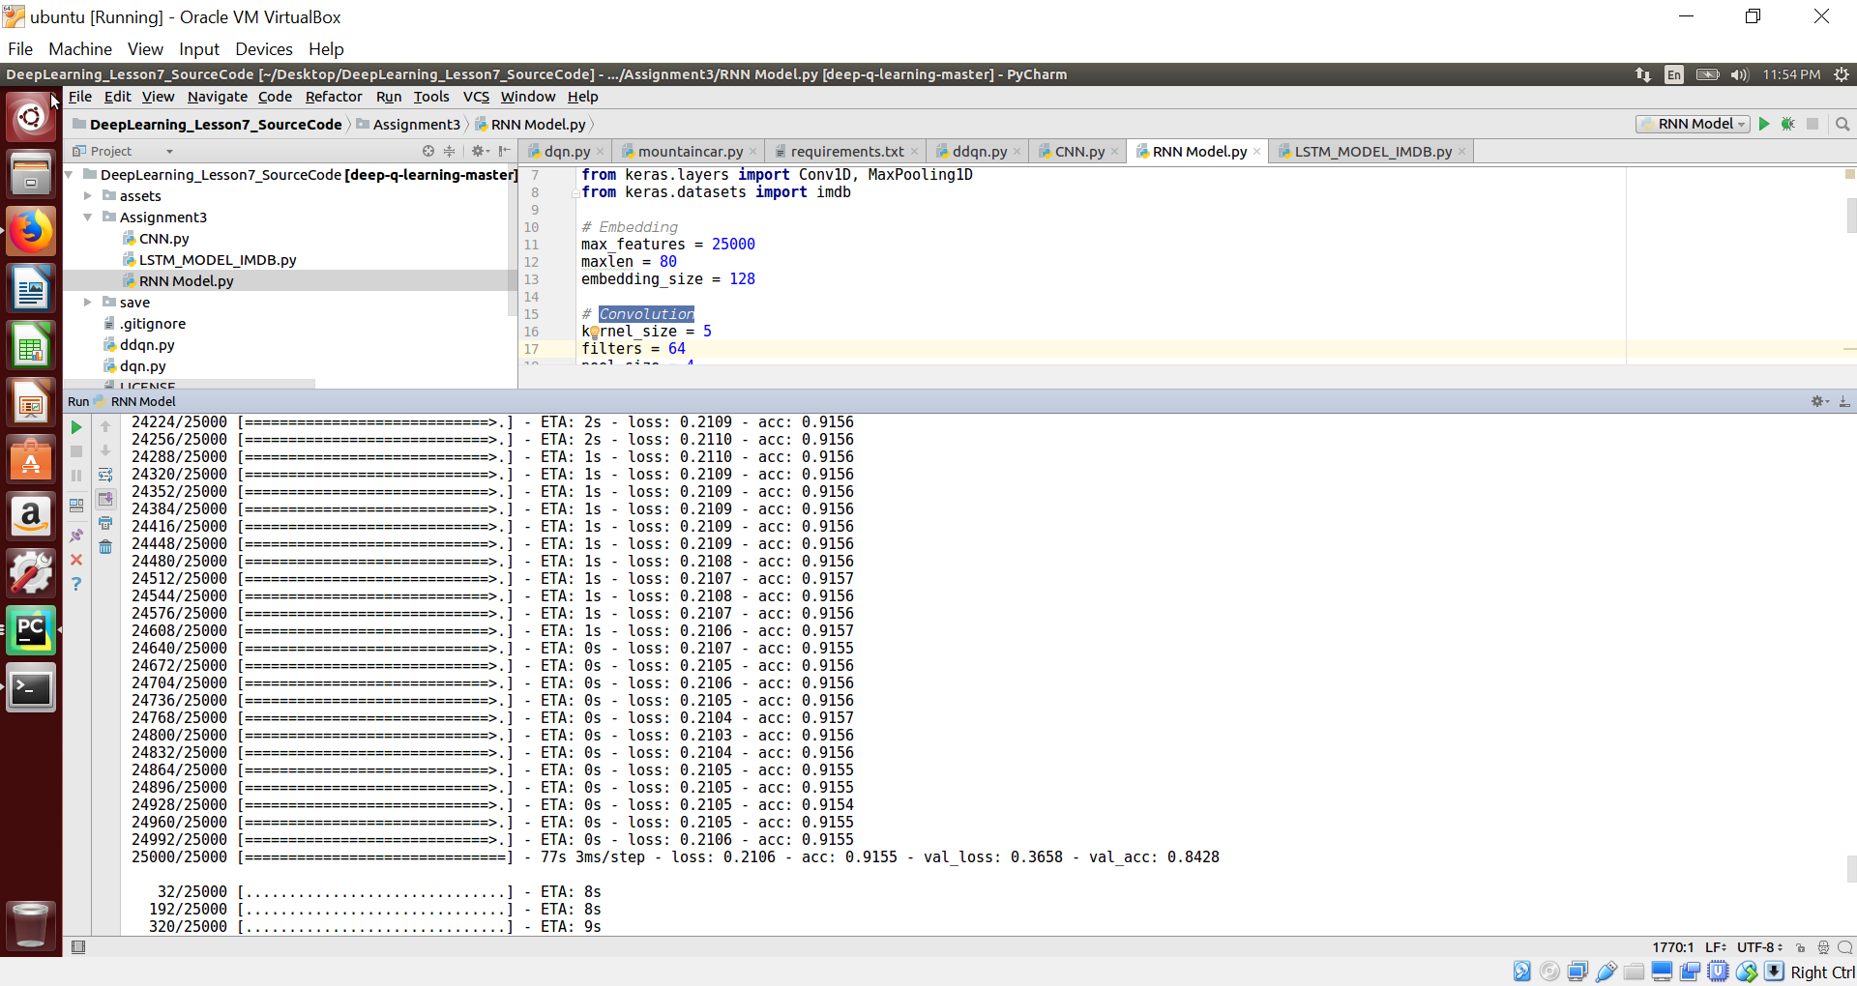

Accuracy of RNN: 0.8428 Loss: 0.3658

**Result:**

|  |  |  |  |  |  |
| --- | --- | --- | --- | --- | --- |
| **Text Classification Technique** | **Dataset** | **No. of Epoch** | **Accuracy** | **Loss** | **Rank** |
| CNN | IMDB | 2 | 0.8696 | 0.3115 | 1 |
| LSTM | IMDB | 15 | 0.8112 | 1.0822 | 3 |
| RNN | IMDB | 2 | 0.8428 | 0.3658 | 2 |

**Conclusion:**

From the above results we can conclude that CNN yields more accurate text classification for our IMDB dataset then RNN and LSTM in order.